Wireframe UI design:

About page:



Figure 1: About page Wireframe

Course and admission page:



Figure 2: course and admission Wireframe

News and event:



Figure : news and event wireframe

Research paper publication page:



Figure : Research paper and publication page Wireframe

Alumni success story:

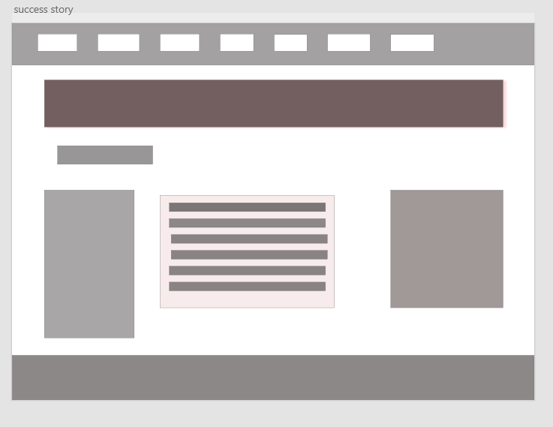

Figure : previous student success story page wireframe